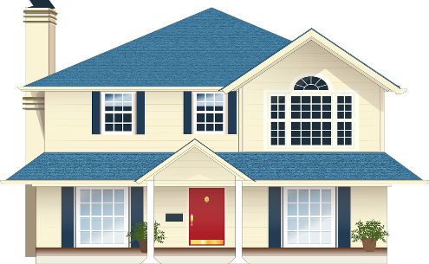
This Photo by Unknown Author is licensed under CC BY-SA-NC

SENIOR HANDYMAN PROGRAM APPLICATION
(All applications will be reviewed by the Borough for approval)

THE HANDYMAN PROGRAM PROVIDES NON-EMERGENCY AND MINOR REPAIRS HELPING SENIORS TO LIVE INDEPENDENTLY AND SAFELY IN THEIR HOMES

This program is for seniors aged 62 and older who need assistance with minor repairs such as window and screen repair, replacement of light bulbs, light carpentry, and much more.

If you are interested, please contact Courtney Agnello at (908) 322-8236 x. 123 or fill out the form below and mail back to Courtney Agnello, Borough Hall, 75 N. Martine Avenue, Fanwood, New Jersey 07023 or email cagnello@fanwoodnj.org.

ALL APPLICANTS ARE RESPONSIBLE FOR THE COST & PROVISION OF ALL MATERIALS/SUPPLIES NEEDED, UNLESS OTHERWISE AGREED UPON!

All information is kept strictly confidential.

NAME: __________________________________________________________ AGE: _____________________

PROPERTY ADDRESS: ______________________________________________________________________

TELEPHONE: _____________________________ CELL PHONE: __________________________________

E-MAIL: ___________________________________________________________________________________

SCOPE OF WORK REQUESTED: ______________________________________________________________

_____________________________________________________________________________________________

APPLICANT SIGNATURE: ___________________________________________DATE: _________________
APPROVAL: Department of Public Works: _____________________________________________________
(Signature and Date)

Name of Assigned Employee: _____________________________________________________
(Print Name)

Clerk’s Office: _________________________________________________________________
(Signature and Date)
Cost of Project Projection:
Parts $___________________ Labor $___________________ Misc $___________________

TOTAL $________________

COMPLETION OF FILE/WORK

Completion Date: ____________________ Applicant Sign-Off: ______________________________________
DPW Representative Sign-Off: _________________________________________________________________

Comments:_________________________________________________________________________________________________________________________________________________________________________________________________________________________________________________________________________________________________________________________________________________________________________________________________________________________________________________________________________________________________________________________________________________________________________________________________________________________________________________________________

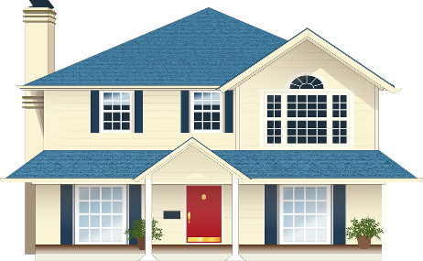
This Photo by Unknown Author is licensed under CC BY-SA-NC

BOROUGH OF FANWOOD

HOLD HARMLESS AGREEMENT

I, (applicant printed name)_______________________________________________, residing at (property address)____________________________________________, Fanwood, New Jersey, 07023 agree to Protect, Indemnify and Hold Harmless the Borough of Fanwood (the “Indemnifier”) from personal liability, claim, suit, loss or damage that may result from my participation in the Handyman Program.

The Borough wishes to minimize any hardship the applicant might suffer as the result of a personal liability, claim, suit, loss, or that may result from the applicant’s (Indemnitee’s) participation in the Handyman Program. Thus, the Borough agrees to indemnify you and hold you harmless from any and all claims, suits, losses, liabilities, judgments, fines, penalties, demands or expenses that involve the Borough of Fanwood, its elected officials, employees, agents, volunteers, servants, or representatives arising out of accidents, injuries or death to persons or losses of or damage to property, or fines or penalties which may result, in whole or in part, by reason of operations involving the handyman program.

____________________________________________ ___________________________
Applicant’s Signature Date

__________________________________________________________________________
Printed Name of Applicant

_________________________________________________________Fanwood, NJ 07023
Property Address

_______________________________________ __________________________________
Indemnifier Signature (Borough Representative) Date

_______________________________________
Printed Name of Representative
Borough of Fanwood
75 N. Martine Avenue
Fanwood, New Jersey 07023

